**SIGN LANGUAGE**

**DETECTION AND RECOGNITION**

**SYSTEM**

**PROJECT REPORT**

SUBMITTED IN PARTIAL FULFILLMENT OF THE REQUIREMENT FOR

MINOR PROJECT

**Duration**

**(From January to April,2024)**

SUBMITTED BY

Yash Raj Suman 2103064 (161/21)

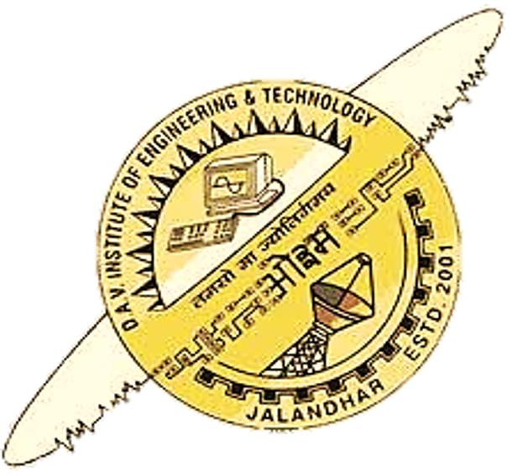

**Department of Computer Science & Engineering**

**DAV Institute of Engineering & Technology**

Jalandhar, India

**Abstract**

Hand sign recognition and detection systems play a pivotal role in enhancing communication for individuals with hearing impairments, especially in regions where specific sign languages, like Hindi, lack sufficient technological representation. This paper presents the development of a comprehensive hand sign recognition and detection system tailored for the Hindi language, employing Python, OpenCV, MediaPipe, and PyQt5 to achieve accurate and efficient real-time performance.

The system leverages MediaPipe's advanced hand tracking capabilities to detect and track hand movements in real-time. OpenCV is utilized for various image processing tasks, including pre-processing input frames, enhancing image quality, and extracting essential features from the detected hand signs. These features are then fed into a robust machine learning model, specifically trained to recognize and classify different Hindi hand signs with high accuracy.

To facilitate user interaction, a graphical user interface (GUI) is developed using PyQt5. The GUI is designed to be user-friendly and intuitive, allowing users to seamlessly interact with the system. It displays the live video feed, highlights the detected hand signs, and provides real-time feedback on the recognized signs and their corresponding meanings. This interface significantly improves the usability of the system, making it accessible to a broader audience, including educators, learners, and individuals with hearing impairments.

The primary goal of this system is to bridge the communication gap for Hindi-speaking individuals with hearing impairments by providing an effective and reliable tool for recognizing and interpreting Hindi hand signs. The system's performance has been evaluated across various environments, demonstrating high accuracy and robustness in different lighting conditions and backgrounds. This reliability makes it a valuable tool for facilitating communication and promoting the use of Hindi sign language.

Future work will focus on expanding the dataset to include a wider range of Hindi hand signs and gestures, further refining the recognition algorithms to handle more complex and dynamic gestures, and optimizing the system for deployment on mobile platforms. Additionally, integrating natural language processing techniques to provide contextual understanding and enhancing the system's real-time processing capabilities will be explored.

Overall, this hand sign recognition and detection system represents a significant advancement in accessibility technology for Hindi sign language, offering a practical solution to improve communication and support the hearing-impaired community.

**Acknowledgement**

I am deeply grateful to Dr. Sanjeev Naval, Principal of DAV Institute of Engineering & Technology, Jalandhar, for providing me with the opportunity to undertake this minor project.

I extend my heartfelt appreciation to Dr. Harpreet Kaur Bajaj, Head of the Department of Computer Science & Engineering at DAVIET Jalandhar, for her unwavering guidance and encouragement, which greatly facilitated the execution of the project.

I would also like to convey my sincere thanks to Mr. Vishwa Mitter, Assistant Professor in the Department of Computer Science & Engineering at DAVIET, Jalandhar, for their invaluable guidance, constant motivation, and supervision throughout this project. their insightful advice and diligent oversight were instrumental in shaping this report.

Furthermore, I express my gratitude to Mr. Vishwa Mitter, Assistant Professor in the Department of Computer Science & Engineering at DAVIET, Jalandhar, the Project Coordinator, for their valuable contributions and support during the development of this project. Their expertise and assistance have significantly enriched the outcome of this endeavor.

Lastly, I extend my thanks to all the faculty members of the Computer Science & Engineering department at DAVIET for their intellectual support and encouragement throughout this endeavor.

**Yash Raj Suman**

**List of Figures**

|  |  |  |
| --- | --- | --- |
| FIG No. | FIG Description | Page no. |
| 2.4a | Agile Model Life Cycle | 7 |
| 3.1a | System Methodology | 8 |
| 3.2a | User Interface Design (video feed: OPEN) | 8 |
| 3.2b | User Interface Design (video feed: CLOSED) | 9 |
| 3.3a | System Design | 9 |
| 3.4a | character prediction flowchart | 10 |
| 3.5a | gesture recognized | 10 |
| 5.1a | User Interface (working) | 13 |
| 5.3a | Interface code | 14 |
| 5.3b | image collection code | 14 |
| 5.3c | dataset matrix code | 14 |
| 5.3d | model training code | 15 |
| 5.4a | Confusion Matrix | 15 |
| 5.4b | Precision (by classes) | 16 |
| 5.4c | Recall (by classes) | 16 |
| 5.4d | F1-Score (by classes) | 17 |

**List of Tables**

|  |  |  |
| --- | --- | --- |
| Table No. | Table Description | Page no. |
| 4.1a | Technologies used | 11 |

**Table of Contents**

|  |  |
| --- | --- |
| Contents | Page No. |
| *Abstract* | *i* |
| *Acknowledgement* | *ii* |
| *List of Figures* | *iii* |
| *List of Table* | *iv* |
| *Table of Contents* | *v* |
| Chapter 1: Introduction----------------------------------------------------------------------------- | 1-4 |
| 1.1 Introduction to Project | 1 |
| 1.2 Project Category | 1 |
| 1.3 Objectives | 1 |
| 1.4 Problem Formulation | 2 |
| 1.5 Identification/Reorganization of Need | 2 |
| 1.6 Existing System | 3 |
| 1.7 Proposed System | 3 |
| 1.8 Unique Features of the System | 4 |
| Chapter 2: Requirement Analysis and System Specification-------------------------------- | 5-7 |
| 2.1 Feasibility study | 5 |
| 2.2 Software Requirement Specification | 6 |
| 2.3 Expected hurdles | 6 |
| 2.4 SDLC model to be used | 7 |
| Chapter 3: System Design--------------------------------------------------------------------------- | 8-10 |
| 3.1 System Methodology | 8 |
| 3.2 User Interface Design | 8 |
| 3.3 System Design | 9 |
| 3.4 Flowchart | 10 |
| 3.5 Gesture Recognized by Model | 10 |
| Chapter 4: Implementation, Testing and Maintenance--------------------------------------- | 11-12 |
| 4.1 Introduction to Languages, IDE’s, Tools and Technologies used for Implementation | 11 |
| 4.2 Coding Standard | 12 |
| Chapter 5: Results and Discussions--------------------------------------------------------------- | 13-17 |
| 5.1 User Interface Representation | 13 |
| 5.2 Brief Description of Various Modules of the system | 13 |
| 5.3 Snapshots of Code | 14 |
| 5.4 System/Model metrics | 15 |
| Chapter 6: Conclusion and Future Scope-------------------------------------------------------- | 18-19 |
| 6.1 Conclusion | 18 |
| 6.2 Future Scope | 18 |
| References | 20 |

Chapter 1: Introduction

* 1. **Introduction to Project**

Human communication thrives on a rich history of languages, each with its own unique grammar, vocabulary, and cultural nuances. Sign language, a visual language expressed through hand gestures, facial expressions, and body posture, serves as a vital communication tool for millions of deaf and hard-of-hearing individuals around the world. However, a significant communication barrier exists between those who use sign language and those who don't. This disparity can hinder social interaction, limit access to information and education, and restrict participation in everyday activities.

This project seeks to bridge this communication gap by developing a groundbreaking Sign Language Detection and Recognition System. This system will harness the power of cutting-edge computer vision and machine learning algorithms to achieve two critical functionalities:

* Detection: Imagine a world where technology can instantly recognize the presence of sign language being used in a visual input, such as a video call, a pre-recorded lecture, or even a live news broadcast. Our system will be equipped to do just that. By analyzing visual data, it will be able to discern between sign language gestures and other forms of movement, ensuring the system focuses its processing power on relevant information.
* Recognition: The true magic lies in the ability to translate the detected signs into a more widely understood format, such as text or spoken language. This system will be trained on a comprehensive dataset of sign language signs, encompassing variations in hand shapes, movements, facial expressions, and regional dialects. Through sophisticated machine learning techniques, the system will learn to recognize these complex patterns and translate them into their corresponding meaning, fostering real-time, two-way communication.

This project has the potential to revolutionize communication accessibility, empowering deaf and hard-of-hearing individuals to interact more seamlessly with the world around them.

* 1. **Project Category**

This project falls under the category of System and Application Development. The system will be designed as a software application that can be used on various platforms, potentially including computers, tablets, and smartphones.

* 1. **Objectives**

The primary objectives of this project are:

* To develop a system that accurately detects hands within video frames.
* To extract key features from the detected hands, such as hand shape, finger configuration, and movement.
* To employ machine learning algorithms to classify and recognize the extracted features, translating them into their corresponding sign language meaning.
* To design a user-friendly interface for interacting with the system.
  1. **Problem Formulation**

The current communication landscape presents a significant challenge for deaf and hard-of-hearing individuals. Sign language, a complete and expressive form of communication in itself, creates a barrier between them and those who rely on spoken or written language. This disparity manifests in several ways, hindering their ability to participate fully in everyday life.

1. **Limited Access to Information:** Educational lectures, news broadcasts, public announcements, and other spoken or written information remain largely inaccessible without sign language interpreters. This restricts deaf and hard-of-hearing individuals' ability to stay informed about current events, pursue educational opportunities, and participate actively in civic life. They may miss out on crucial details during lectures or presentations, struggle to follow fast-paced conversations on news broadcasts, and face difficulties understanding public announcements.
2. **Hindered Social Interactions:** Real-time communication between individuals who use sign language and those who don't often requires the presence of sign language interpreters. This dependency can create delays in communication, disrupt the natural flow of conversation, and limit opportunities for spontaneous interaction. Social settings can become frustrating and isolating for deaf and hard-of-hearing individuals as they wait for interpretation or struggle to convey their thoughts and feelings in a timely manner.
3. **Restricted Employment Opportunities:** The communication barrier can also hinder employment opportunities for deaf and hard-of-hearing individuals. Job interviews, meetings, and workplace interactions can all pose challenges without access to real-time sign language interpretation. They may struggle to effectively express their qualifications during interviews, miss out on important details during meetings, and face difficulties collaborating with colleagues. This can limit career advancement and participation in the workforce, leading to feelings of frustration and exclusion.
   1. **Identification/Reorganization of Need**

The core need lies in facilitating seamless communication between those who use sign language and those who don't. This encompasses several sub-needs that are crucial for an effective solution:

1. **Accurate Sign Language Detection:** The system needs to reliably distinguish sign language gestures from other movements in video or images, even in challenging conditions. This might involve factors like background clutter, variations in lighting, overlapping hand signs, or individual signing styles. A robust detection system ensures the system focuses its processing power on relevant information and minimizes false positives (mistaking non-sign movements for signs).
2. **Robust Sign Recognition:** The system must translate specific signs into text or spoken language with high accuracy, encompassing variations in signing styles and dialects. Sign languages can have regional variations, and individual signing styles may incorporate subtle nuances. The system needs to be trained on a comprehensive dataset that captures this diversity and utilizes machine learning algorithms to recognize these complex patterns with a high degree of accuracy.
3. **Real-Time Performance:** Delays in detection and recognition hinder communication flow and can be frustrating for users. The system needs to provide near-instantaneous results, ensuring a smooth and natural communication experience. This requires efficient processing algorithms and optimized software to minimize latency between sign language input and text/speech output.
4. **Accessibility and User-Friendliness:** The system should be accessible across various platforms (e.g., mobile apps, web interfaces, video conferencing tools) to cater to a broad range of users. Additionally, the user interface should be intuitive and user-friendly for both deaf and hard-of-hearing individuals and those interacting with them. This may involve features like customization options, clear visual feedback, and compatibility with assistive technologies.

By addressing these sub-needs, the project can create a more inclusive communication experience.

* 1. **Existing System**

Currently, several approaches exist to bridge the communication gap:

1. **Sign Language Interpreters:** Human interpreters are the primary method for real-time communication between sign language and spoken language users. However, interpreter availability, cost, and potential delays limit their practicality.
2. **Text-Based Communication:** SMS, email, and messaging apps enable communication, but they lack the natural flow and expressiveness of sign language.
3. **Assistive Technologies:** Some specialized software and hardware tools exist for sign language recognition, but they often have limitations in accuracy, real-time performance, or widespread accessibility.

These existing systems have limitations that restrict their effectiveness in addressing the overall communication gap.

* 1. **Proposed System**

Sign Language Detection and Recognition System directly addresses the limitations of existing solutions and aims to be widely accessible, cost-effective, and user-friendly. Here's a breakdown of its key functionalities:

1. **Sign Language Detection:** The system will employ advanced computer vision algorithms to analyze video input from various sources, such as webcams, pre-recorded videos, or video calls. These algorithms will be trained to identify the presence of sign language gestures with high accuracy, even in dynamic environments with potential variations in lighting, background clutter, or individual signing styles.
2. **Sign Recognition:** Once sign language is detected, the system will leverage a comprehensive dataset encompassing a vast array of signs. This dataset will account for variations in hand shapes, orientations, movements, facial expressions, and potential regional dialects. By employing machine learning techniques, the system will be able to recognize complex sign language patterns and translate them into their corresponding meaning, either as text or spoken language, with a high degree of accuracy.
3. **Real-Time Processing:** To facilitate seamless communication, the system will be optimized for efficient processing. This will ensure near-instantaneous results, minimizing delays between sign language gestures and their corresponding text or spoken language output. This real-time functionality is crucial for natural and uninterrupted conversations.

This system aims to foster real-time communication and promote inclusivity for deaf and hard-of-hearing individuals.

* 1. **Unique Features of the System**

Sign Language Detection and Recognition System goes beyond existing solutions by incorporating several unique features:

1. **Webcam based Support:** Unlike many existing systems that focus solely on webcam video, our system will be designed to handle diverse input formats. This could include pre-recorded videos, video calls, or even images containing static sign language gestures. This versatility allows for broader application and accessibility.
2. **Background Noise Reduction:** Real-world scenarios often involve backgrounds with varying levels of clutter. Our system will incorporate algorithms that effectively differentiate between sign language gestures and background elements. This ensures accurate detection even in less-than-ideal environments.

Chapter 2: Requirement Analysis and System Specification

* 1. **Feasibility study**

This feasibility study analyzes the potential of developing a Sign Language Detection and Recognition System. It will explore three key aspects: technical, economic, and operational feasibility.

* **Technical Feasibility:**
* **Strengths:** Advancements in computer vision and machine learning offer promising tools for gesture recognition and pattern identification. Existing datasets of sign language signs can be leveraged for training the system.
* **Challenges:** Developing algorithms robust enough to handle variations in signing styles, background clutter, and lighting conditions requires significant expertise. Additionally, ensuring real-time processing with high accuracy presents a technical hurdle.
* **Overall Assessment:** Technical feasibility is considered moderate to high. With dedicated research and development efforts, overcoming these challenges is achievable.
* **Economic Feasibility:**
* **Costs:** Development costs include hiring skilled personnel in computer vision, machine learning, and software engineering. Data acquisition and system maintenance also require ongoing investment.
* **Benefits:** Potential benefits include increased accessibility for deaf and hard-of-hearing individuals, improved communication in educational and professional settings, and a larger market for sign language learning resources. Additionally, licensing the technology or offering it as a service could generate revenue streams.
* **Overall Assessment:** Economic feasibility depends on securing funding for development and striking a balance between development costs and potential revenue streams. Conducting market research to gauge potential user base and pricing strategies is crucial.
* **Operational Feasibility:**
* **Strengths:** The system can be designed to integrate with existing communication platforms like video conferencing tools or educational software. Additionally, a user-friendly interface can make the system accessible to users with varying technical expertise.
* **Challenges:** User adoption and training might be required depending on the system's complexity. Additionally, integrating the system with various platforms might necessitate collaboration with different software providers.
* **Overall Assessment:** Operational feasibility is considered moderate. User-centered design principles and effective training materials can address user adoption challenges. Collaboration with relevant stakeholders can facilitate integration with existing platforms.
  1. **Software Requirement Specification**

1. **Data Requirements**

* **Video:** Input data stream from webcams, pre-recorded videos, or video calls.
* **Images:** Static images containing sign language gestures (optional).
* **Sign Language Data:** Extensive dataset of ASL signs with variations in hand shapes, orientations, movements.
* **System Configuration**: User preferences for output format (text or spoken language).

1. **Functional Requirements**

* **Sign Language Detection:**
* The system shall accurately identify the presence of sign language gestures within the video or image input.
* It shall function in various lighting conditions and handle background clutter effectively.
* **Sign Language Recognition:**
* The system shall recognize a comprehensive set of ASL signs with high accuracy.
* It shall account for variations in signing styles due to personal preferences or regional dialects.
* The system shall translate recognized signs into text or spoken language.
* **User Interface:**
* The system shall provide a user-friendly interface for configuration and interaction.
* Users shall be able to select preferred output formats (text or spoken language).

1. **Performance Requirements**

* The system shall achieve near-real-time performance with minimal latency between sign detection and recognition.
* It shall be optimized for efficient processing on various computing platforms.

1. **Dependability Requirements**

* Availability: The system should be available for use with minimal downtime.
* Reliability: The system should consistently perform its designated functions with minimal errors.
  1. **Expected hurdles**
* **Data Acquisition and Diversity:** Building a comprehensive dataset encompassing a vast array of signs, variations, and regional dialects requires significant effort. Ensuring data quality and representation of diverse signing styles is crucial for accurate recognition.
* **Background Clutter and Lighting:** Real-world environments often involve dynamic backgrounds and varying lighting conditions. Training the system to effectively differentiate between sign language gestures and background elements while adapting to different lighting scenarios requires sophisticated algorithms.
* **Real-Time Processing:** Achieving near-real-time performance with high accuracy is a significant challenge. Balancing processing speed with accurate recognition necessitates efficient algorithms and optimized hardware utilization.
  1. **SDLC model to be used**

The **Agile model** is an iterative and incremental development approach that prioritizes flexibility and continuous improvement. It would be well-suited for this project due to the following reasons:

* **Uncertain Requirements:** The project involves cutting-edge technologies and may require adapting functionalities as development progresses. Agile's iterative nature allows for incorporating new ideas and feedback throughout the process.
* **Rapid Prototyping:** Agile emphasizes building and testing functional prototypes early on. This allows for early validation of core functionalities like sign detection and recognition, ensuring the system is on the right track.
* **User Feedback Integration:** Agile promotes close collaboration with stakeholders, including deaf and hard-of-hearing communities. This ongoing feedback loop ensures the system addresses user needs and is designed for usability.

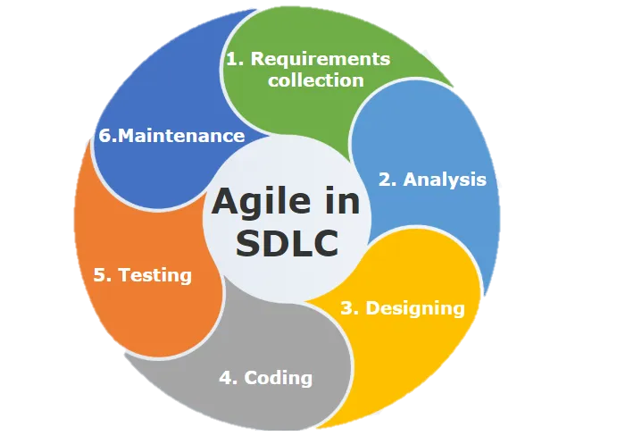

Fig 2.4a: Agile Model Life Cycle

Chapter 3: System Design

* 1. **System Methodology**



Fig 3.1a: System Methodology

* 1. **User Interface Design**

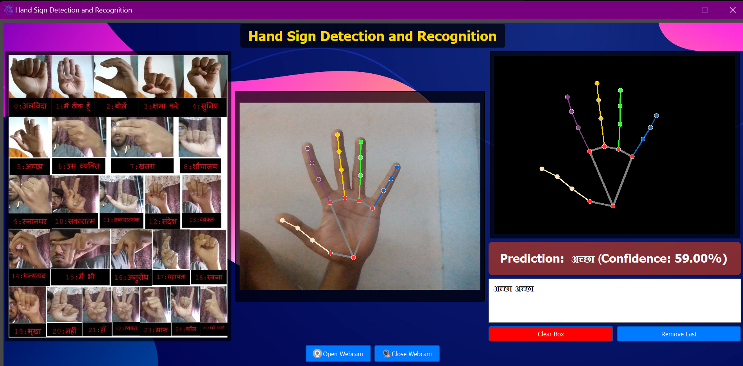

Fig 3.2a: User Interface Design (video feed : OPEN)

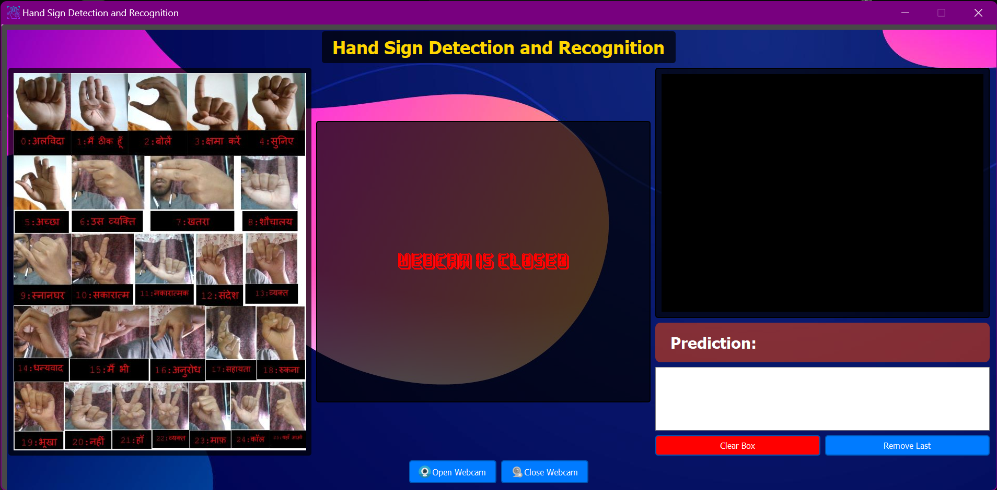

Fig 3.2b: User Interface Design (video feed : CLOSED)

* 1. **System Design**

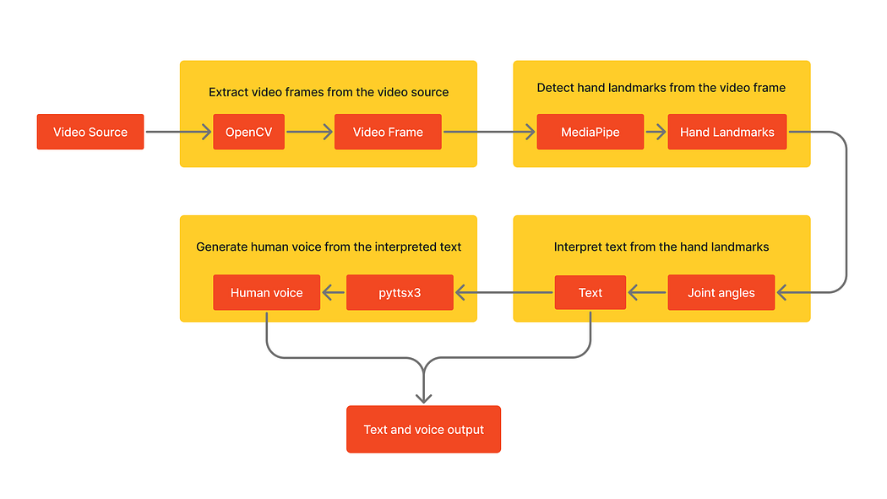

Fig 3.3a: System Design

**3.4 Flowchart**



Fig 3.4a: character prediction flowchart

**3.5 Gesture Recognized by Model**

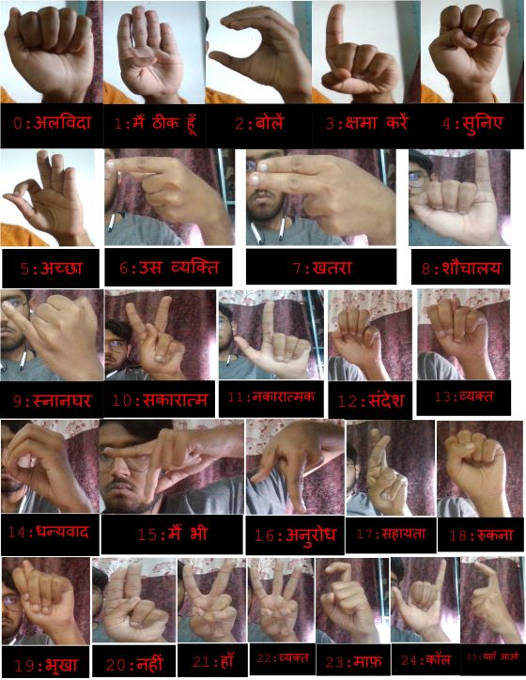

Fig 3.5a: gesture recognized

Chapter 4: Implementation, Testing and Maintenance

* 1. **Introduction to Languages, IDE’s, Tools and Technologies used for Implementation**

SLDRS requires a combination of programming languages, Integrated Development Environments (IDEs), tools, and technologies. Here's an overview

1. **Programming Languages:**

Python: A popular and versatile language known for its readability, extensive libraries, and large developer community.

**2. Integrated Development Environments (IDEs):**

PyCharm: A popular IDE specifically designed for Python development, offering features like code completion, debugging tools, and integration with version control systems.

1. **Major Technologies:**

* OpenCV (Open-Source Computer Vision Library): An open-source library offering a comprehensive set of functions for real-time computer vision tasks like image and video processing, object detection, and feature extraction.
* TensorFlow: Popular deep learning frameworks used for building, training, and deploying machine learning models. These frameworks will be crucial for developing the core sign recognition engine of the SLDRS.
* MediaPipe: An open-source framework from Google that provides pre-built machine learning pipelines for vision, audio, and text tasks. MediaPipe's pre-trained hand tracking model can be a valuable starting point for sign language detection within the SLDRS.
* PyQt: A Python framework for creating cross-platform desktop applications with a user-friendly graphical interface. PyQt will be instrumental in developing the user interface for the SLDRS, allowing users to interact with the system and see the recognition results.

Table 4.1a : Technologies used

|  |  |
| --- | --- |
| **All technologies used** | **Description** |
| OpenCV | An open-source library offering a comprehensive set of functions for real-time computer vision tasks like image and video processing, object detection, and feature extraction. |
| MediaPipe | An open-source framework from Google that provides pre-built machine learning pipelines for vision, audio, and text tasks. |
| PyQt | A Python framework for creating cross-platform desktop applications with a user-friendly graphical interface. |
| Pycharm | A popular IDE specifically designed for Python development, offering features like code completion, debugging tools, and integration with version control systems. |
| Git | A distributed version control system essential for tracking code changes, collaboration among developers, and easier rollbacks if necessary. |
| Scikit-Learn | A popular machine learning library for Python that provides a range of classification, regression, clustering, and dimensionality reduction algorithms. |
| NumPy | A fundamental library for scientific computing in Python. It provides efficient multi-dimensional array structures (ndarrays) and a rich collection of mathematical functions. |

**4.2 Coding Standard**

* Used lowercase with underscores for multiple words while defining variables
* Used 4 spaces for indentation to maintain consistent and readable code.
* Use uppercase letters with underscores to represent constants
* Included descriptive comments to explain the purpose of functions, classes, and complex algorithms.
* Followed the principles of modular programming by breaking code into reusable and logically coherent modules, classes, and functions.

Chapter 5: Results and Discussions

**5.1 User Interface Representation**

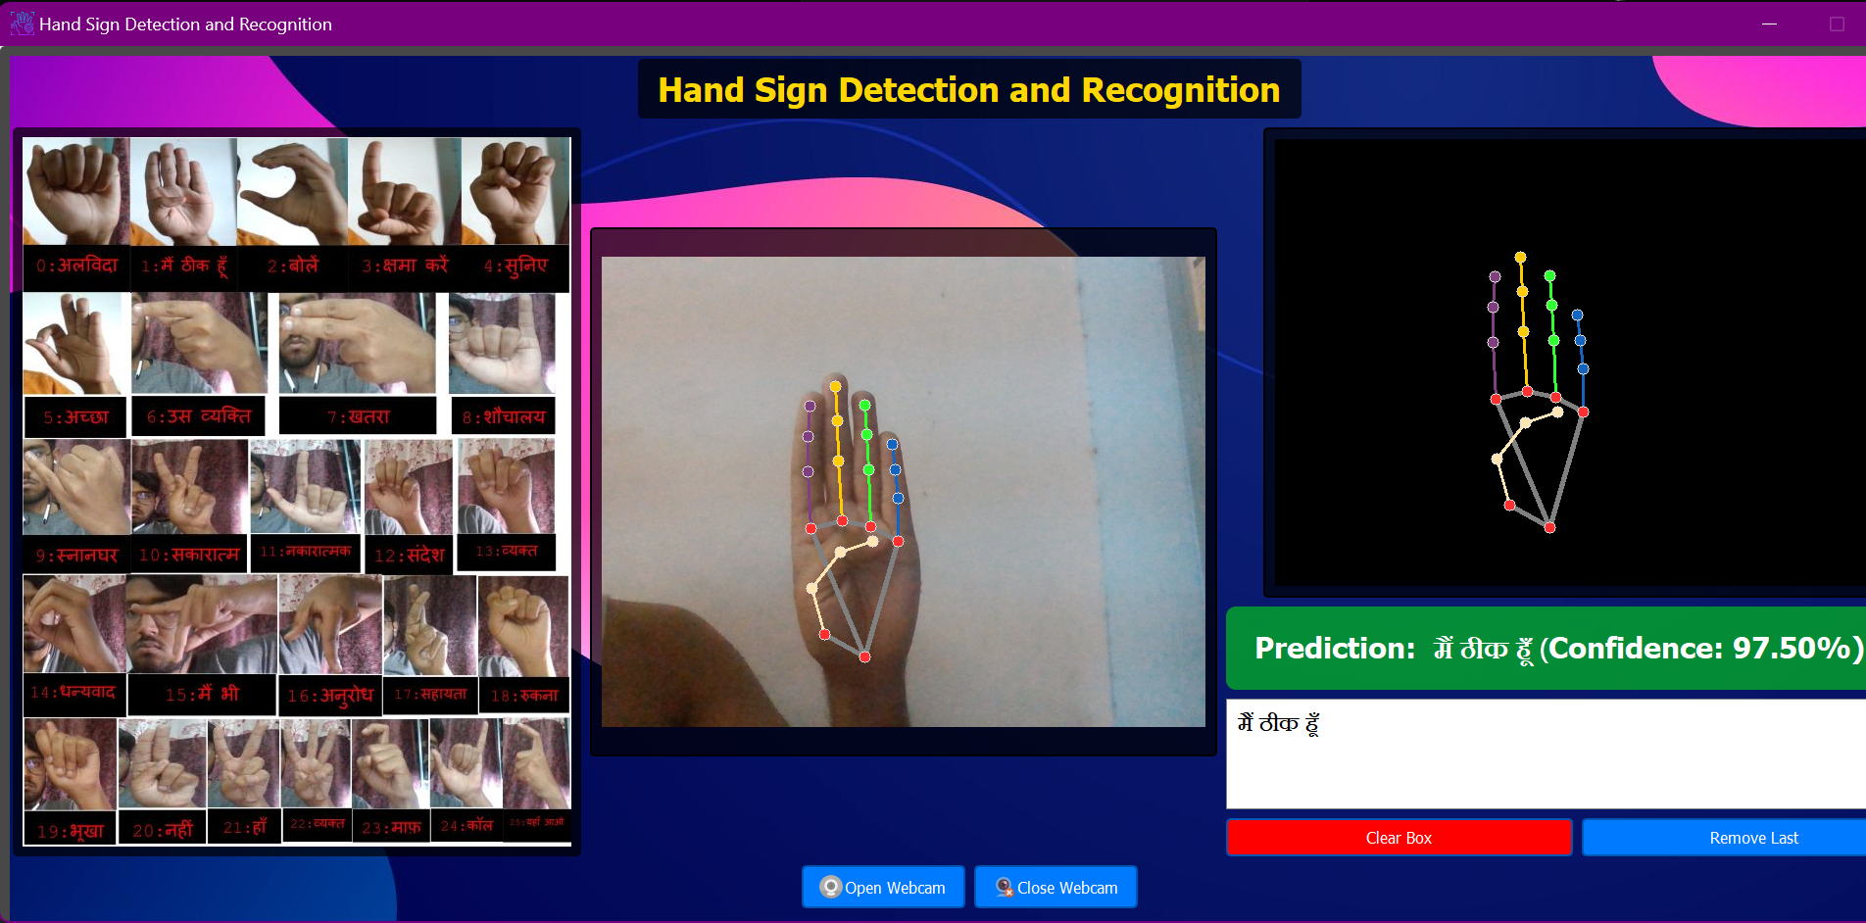

**HAND LANDMARKS**

**SIGN CLASSIFICATION**

**VIDEO FEED**

**HAND GESTURES**

**TEXT BOX**

Fig 5.1a: User Interface (working)

**5.2 Brief Description of Various Modules of the system**

* + **Video feed:** This is the live input video stream captured from the webcam. It provides real-time visual data of the user's hand gestures.
  + **Hand landmarks:** This component extracts features from the video feed when hands are detected. It uses techniques such as MediaPipe to identify and track specific points or landmarks on the hand, which are crucial for understanding gestures.
  + **Sign Classification:** Once hand landmarks are extracted, the system predicts the class or value of the hand gesture being made. This prediction is based on a machine learning model trained to recognize and classify different sign language gestures.
  + **Text box:** The predicted value or class of the hand gesture is displayed in a text box. This provides immediate feedback to the user about the recognized sign language gesture.
  + **Hand Gestures:** This component displays visual representations of the hand gestures that the model can recognize. It helps users understand which gestures are supported and aids in learning and practicing sign language.

**5.3 Snapshots of Code**

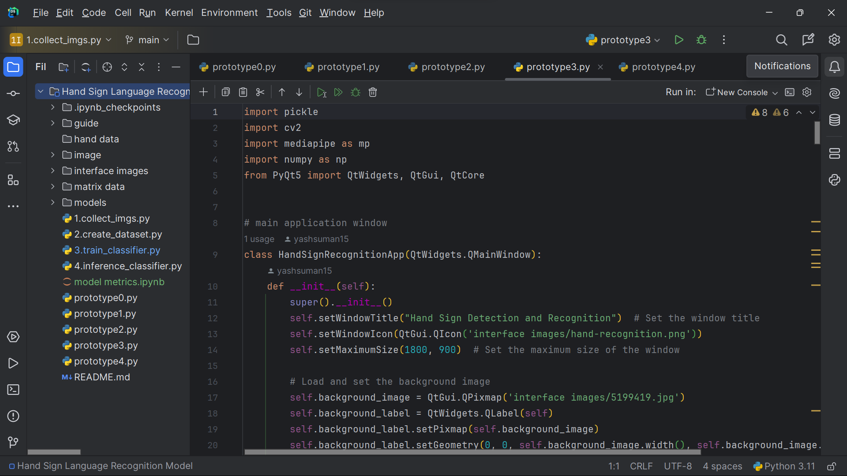

Fig 5.3a: Interface code

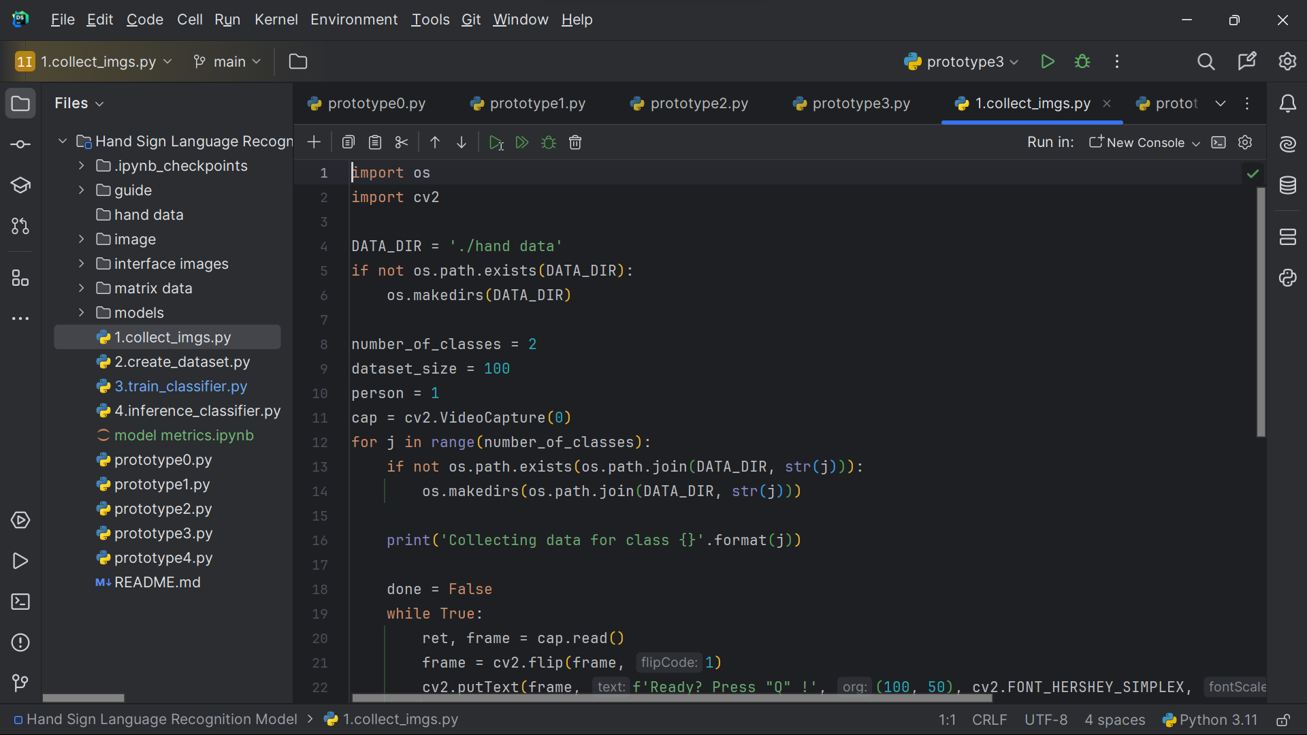

Fig 5.3b: image collection code

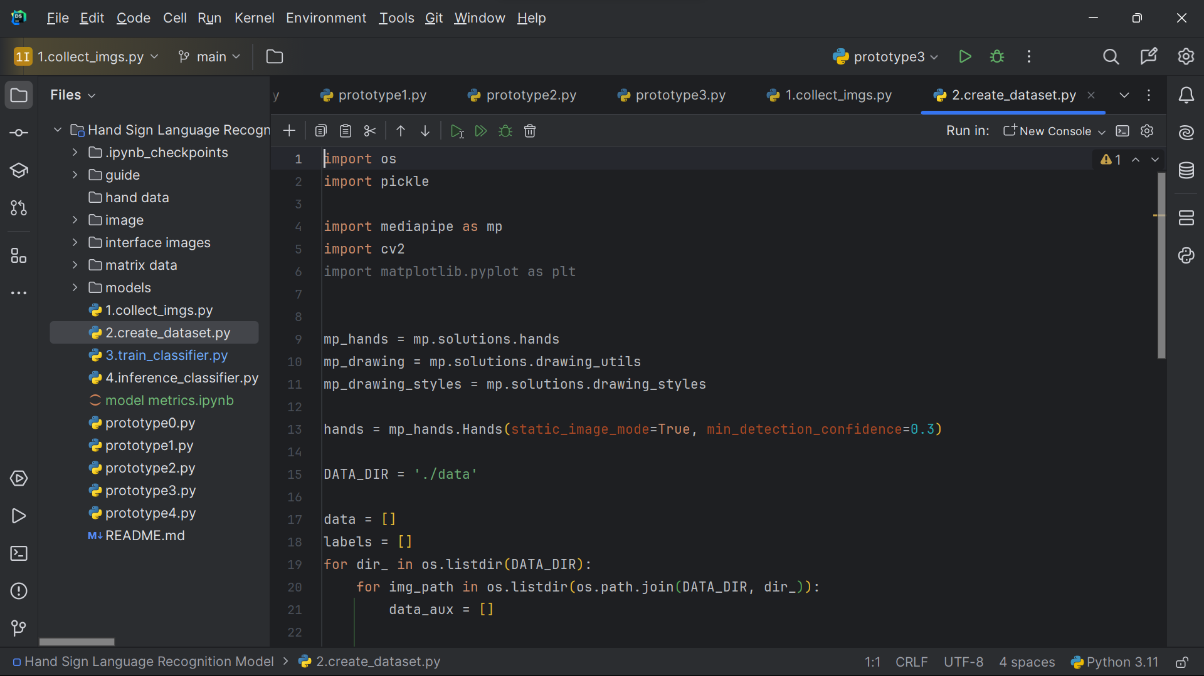

Fig 5.3c: dataset matrix code

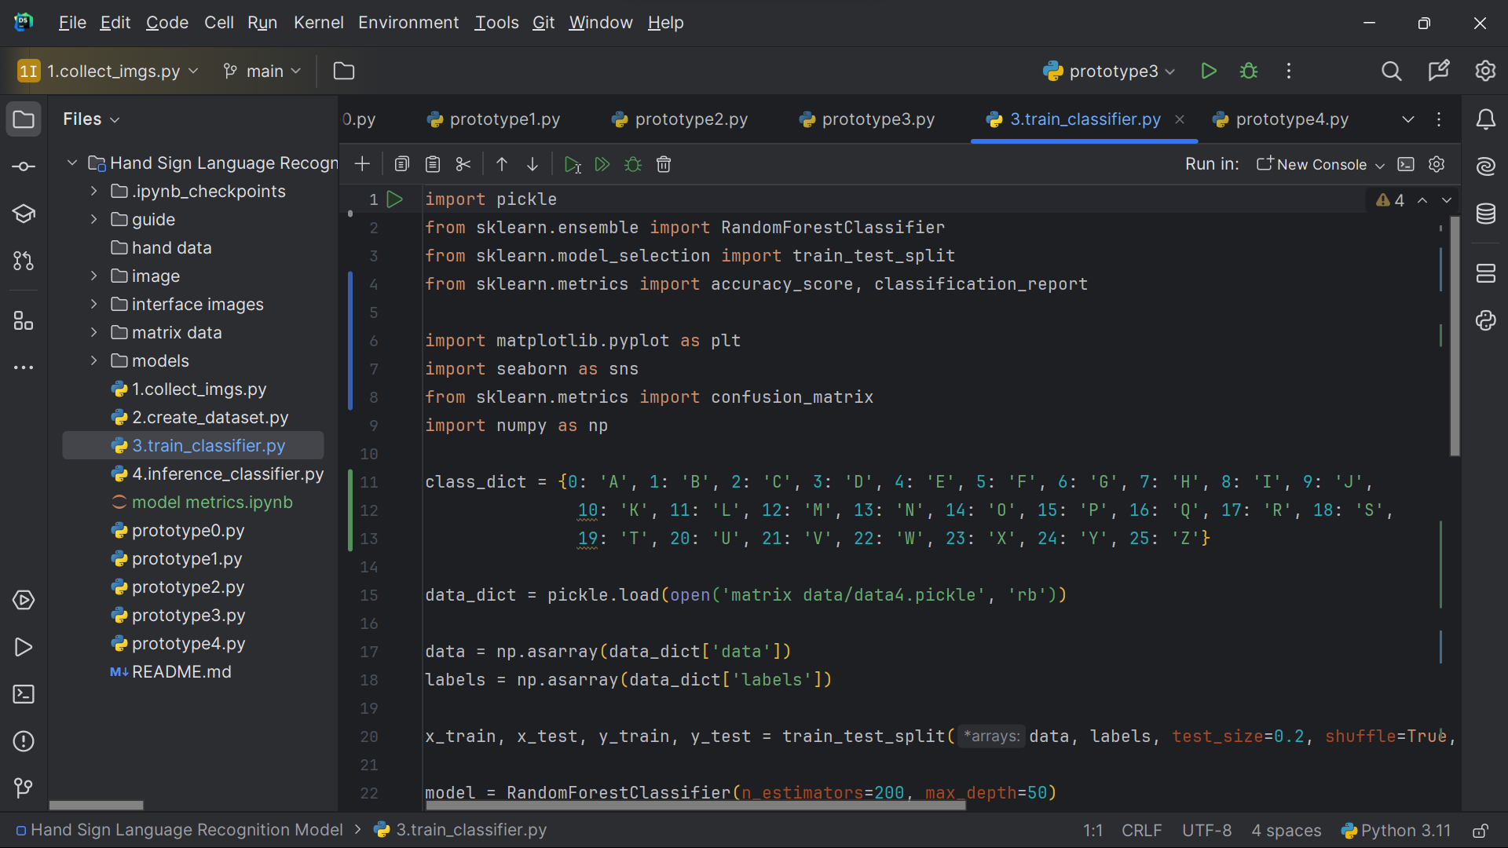

Fig 5.3d: model training code

**5.4 System/Model metrics**

1. **Confusion Matrix**

A confusion matrix is a table used to evaluate the performance of a classification model. It shows the number of true positives (correctly predicted positive instances), true negatives (correctly predicted negative instances), false positives (incorrectly predicted positive instances), and false negatives (incorrectly predicted negative instances).

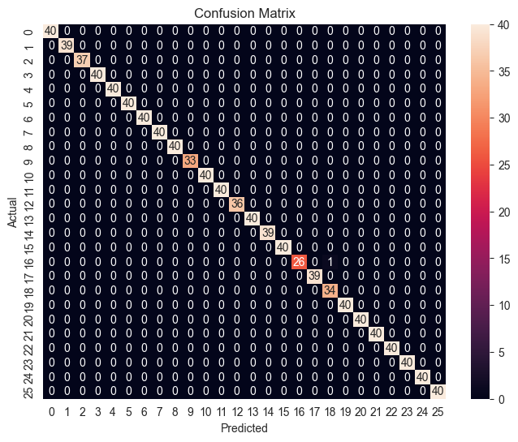

Fig 5.4a: Confusion Matrix

1. **Precision**

Precision measures the accuracy of positive predictions. It's the ratio of true positives to the sum of true positives and false positives. High precision means fewer false positives.

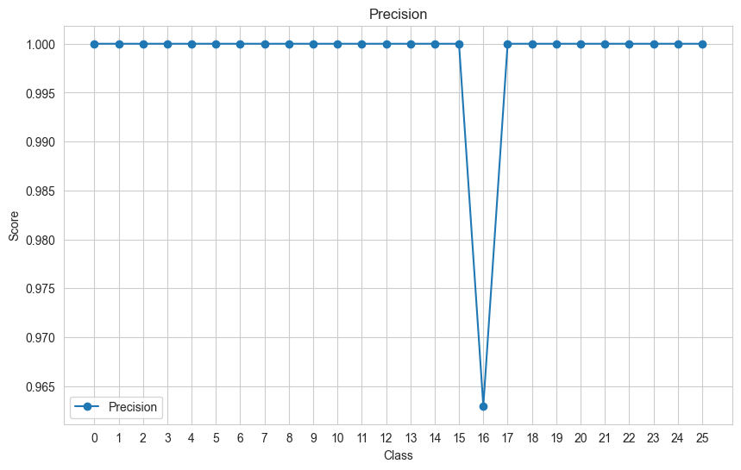

Fig 5.4b: Precision (by classes)

1. **Recall**

Recall (also called sensitivity or true positive rate) measures the ability of the model to identify all relevant instances. It's the ratio of true positives to the sum of true positives and false negatives. High recall means fewer false negatives.

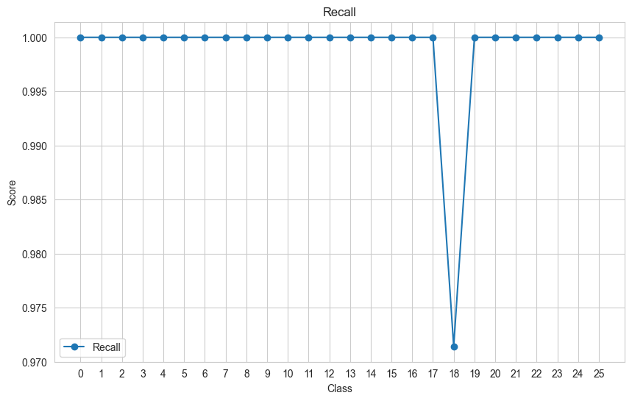

Fig 5.4c: Recall (by classes)

1. **F1-Score**

F1-score is the harmonic mean of precision and recall. It gives a balance between precision and recall. High F1-score indicates both good precision and recall, making it a useful metric for overall model performance.

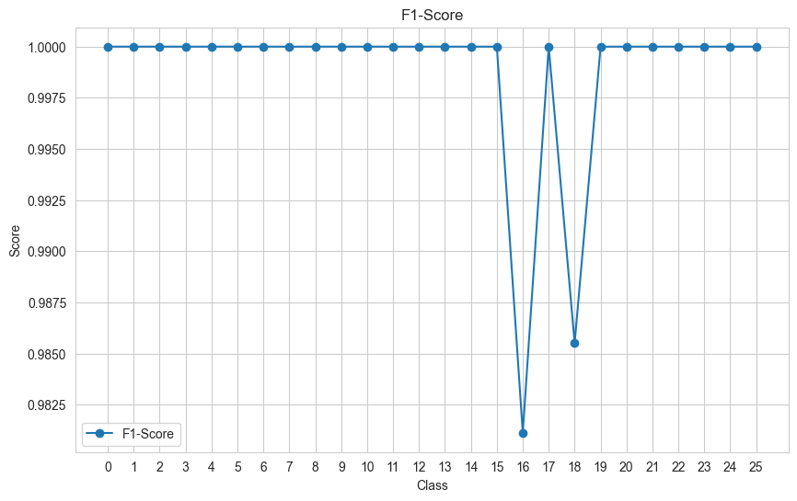

Fig 5.4d: F1-Score (by classes)

Chapter 6: Conclusion and Future Scope

**6.1 Conclusion**

1. Developed real-time hand gesture detection and classification system using webcam input, enabling instant recognition of sign language gestures.
2. Achieved high accuracy rates in identifying and predicting various sign language gestures, ensuring reliable communication support.
3. Created an intuitive interface for displaying real-time results, enhancing user experience and accessibility.
4. Demonstrated strong performance metrics, including high precision and recall, indicating the system's effectiveness in recognizing hand gestures.
5. Enhanced communication accessibility for sign language users, bridging gaps in linguistic interaction.
6. Conducted thorough testing and evaluation to validate system functionality and performance.
7. Integrated MediaPipe technology for efficient hand landmark extraction and feature analysis, optimizing gesture recognition capabilities.
8. Provided real-time feedback through a text box, offering immediate interpretation of detected gestures.
9. Contributed to advancements in assistive technology, particularly in the realm of communication accessibility.
10. Positioned the project as a valuable resource in the field of accessibility solutions and inclusive design.

**6.2 Future Scope**

1. **Multi-Gesture Recognition:** Expand the system to recognize a wider range of sign language gestures and gestures from other domains, enhancing its utility and versatility.
2. **Improved Accuracy:** Further refine the machine learning models to achieve even higher accuracy rates in gesture recognition, ensuring reliable and precise communication support.
3. **Gesture Translation:** Integrate features for translating recognized gestures into text or speech, facilitating seamless communication between sign language users and non-signers.
4. **Mobile Application:** Develop a mobile version of the system for on-the-go accessibility, allowing users to utilize gesture recognition capabilities on smartphones and tablets.
5. **User Customization:** Implement customization options for users to personalize gesture recognition settings and adapt the system to individual preferences and needs.
6. **Interactive Learning:** Incorporate interactive learning modules to help users learn and practice sign language gestures effectively, turning the system into a comprehensive educational tool.
7. **Cloud Integration:** Explore cloud-based solutions for scalability and accessibility, enabling users to access the system from various devices and locations with ease.
8. **Gesture History and Analytics:** Add features to track and analyze gesture usage over time, providing insights into communication patterns and optimizing user experience.
9. **Cross-Platform Compatibility:** Ensure compatibility with different operating systems and hardware setups, expanding the reach of the system to a broader user base.
10. **Collaborative Features:** Enable collaborative gesture recognition for group interactions, supporting communication among multiple users simultaneously.

References

1. MediaPipe. (2024, Feb 29). MediaPipe: A framework for building multimodal (vision, audio, and/or sensor-based) applied machine learning pipelines. Retrieved from <https://developers.google.com/mediapipe/>
2. S. Deshpande and R. Shettar, "Hand Gesture Recognition Using MediaPipe and CNN for Indian Sign Language and Conversion to Speech Format for Indian Regional Languages," 2023 7th International Conference on Computation System and Information Technology for Sustainable Solutions (CSITSS), Bangalore, India, 2023, pp. 1-7, doi: 10.1109/CSITSS60515.2023.10334218.
3. K. K. Dutta and S. A. S. Bellary, "Machine Learning Techniques for Indian Sign Language Recognition," 2017 International Conference on Current Trends in Computer, Electrical, Electronics and Communication (CTCEEC), Mysore, India, 2017, pp. 333-336, doi: 10.1109/CTCEEC.2017.8454988.
4. Python Software Foundation. (2024). Python 3.12.1 documentation. Python Software Foundation.
5. OpenCV. (2024). OpenCV 4.6.0 documentation. OpenCV Foundation.
6. Riverbank Computing Limited. (2022). PyQt6 Reference Guide. Riverbank Computing Limited.